FIDE AID PACKAGE PROJECT 2022 – LIST OF SELECTED OPENS
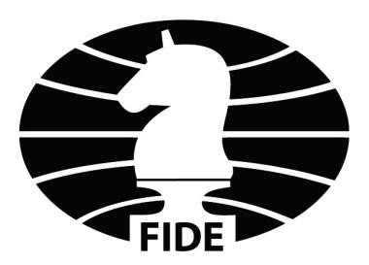
COUNTRY | EVENT | DATES
AND | Andorra Open | July
ARG | Mar del Plata Open | 9-16.04
BAN | Dhaka Open | March - April
BRA | Rio, Duchamp | 10-18.12
BRB | Heroes Day Cup, Bridgetown | 27.04-2.05
CAN | Quebec Open Championship Montreal, | TBA
COL | Onen of Santafe, Bogota | 13-18.12
CPV | Cape Verde open, Mindelo | 22-30.04
CRI | Metropolitano International Tournament, San Jose | 26-31.12
CRO | Krunoslav Hulak Memorial, Zagreb | 2-9.07
CUB | Capablanca Memorial, La Habana | 2-13.05
CZE | Prague International Festival | 7-17.06
ENG | Caplin Hastings Masters | 29.12-6.01
ESP | Sunway Sitges | 11-22.12
FRA | Cannes International Festival | 21-27.02
GEO | Gaprindashvili & Chiburdanidze Cups, Tbilisi | September - October
GRE | Kavala Open | 31.07-7.08
GUM | Guam Open | 12-17.12
GGY | Guernsey International Festival | 16-22.10
ISL | Reykjavik Open | 6-12.04
ITA | Arco Open | 8-16.10
KEN | Kenia Open Championship, Nairobi | 14-18.04
LAT | Technical University Open | 13-21.08
LBN | Beirut Open | 11-20.11
MKD | Karpos Open, Skopje | October
MNE | International Open “Sozina” | TBA
MWI | Lilongwe Open | TBA
MYS | Malaysian Chess Festival, Kuala Lumpur | 2-10.09
NED | Hoogoveen Chess | 15-22.10
NOR | Kragero Resort Chess International | 23-27.02
PHI | Philippines International Championship, Olongapo City | 14-21.10
POL | International Festival “Cracovia”, Krakow | 27.12-04.01
POR | Terras de Tras-os-Montes, Mirandela | 1-7.07
RSA | South African Open, Cape Town | June
RUS | Chigorin Memorial, St-Petersburg | 22-30.10
SOL | Solomon Islands Chess Championship, Honiara | TBA
SRB | Serbia Open, Belgrade | 28.06-6.07
SRI | SFSL Golden Jubilee Open, Colombo | 17-28.06
SUI | Biel Chess Festival | 9-23.07
SVK | Skalica Chess Festival | 20-28.08
SWE | Uppsala Young Champions | 28.10-2.11
THA | Bangkok Chess Club Open | 4-9.04
TTO | Trinidad and Tobago International Open, Port of Spain | 1-8.07
TUN | Bicapawn International Open, Sousse | 15-29.06
UGA | Uganda Open, Kampala | February
UKR | Bridges of Ingul, Mykolaiv | 22-28.06
URU | Marcel Duchamp Cup, Montevideo | 12-19.02
USA | U.S. Masters Championship, Charlotte | 23-27.11
WLS | South Wales International Open, Wales | July-August
ZWE | Zimbabwe Easter Open, Harare | 15-18.04

